Folder table does not show all folders and pagination not working

* 1. Create more than 3 folders ( 5 folders)
  2. Select project to load folder

Expected result: Folder table has two pages and lists 3 folders in first page and 2 more in second page

Actual result: Folder table has only one page in spite of correct returning result from the api

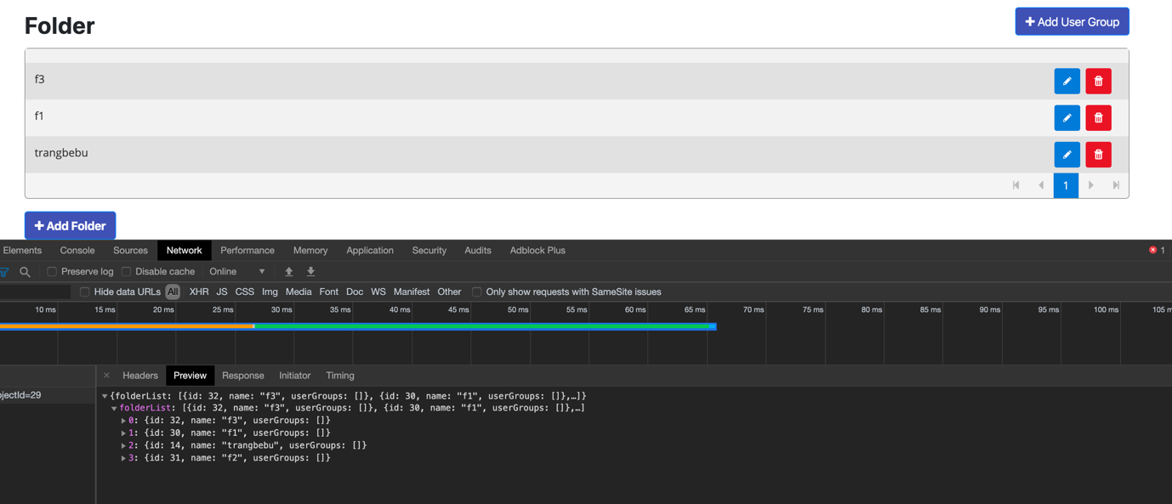

* 1. The pagination does not work since the above issue